**LAB REPORT: 4**

Name: Arghya Roy

Roll Number: 2021115008

Group: 8

Aim/Objective of the experiment: To design an Arithmetic Logical Unit (ALU) capable of performing 8 arithmetic/logic functions on 1 bit operands.

Electronic components used: 1 Arduino board, two 1 kilo ohm resistors, 2 LEDs, 3 hex inverters(74HC04), 8 dual 4-input AND gates(74HC21), 5 quad OR gates(74HC32), 3 quad AND gates(74HC08), 1 quad XOR gate, wires

Reference Circuit:

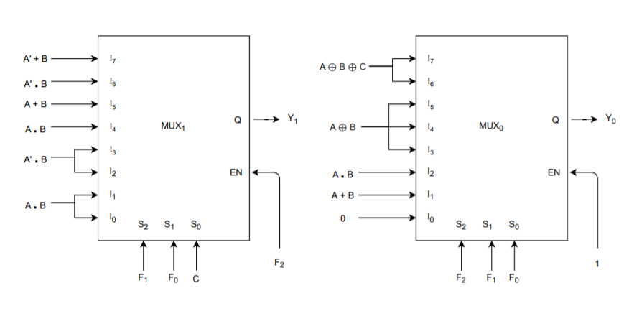

Procedure:

1. The ALU is designed in accordance with the circuit diagram above.
2. F0, F1, F2, A, B and C are taken as inputs from the Arduino with appropriate code.
3. All the input combinations are applied one by one and the observed output Y0 and Y1 are tabulated.

The code:

int f0,f1,f2,a,b,c;

void setup()

{

pinMode(2,OUTPUT);

pinMode(3,OUTPUT);

pinMode(4,OUTPUT);

pinMode(7,OUTPUT);

pinMode(6,OUTPUT);

pinMode(5,OUTPUT);

Serial.begin(9600);

}

void loop()

{

if(Serial.available()>0)

{

f0=Serial.read();

f0=f0-'0';

digitalWrite(2,f0);

Serial.print("\nF0: ");

Serial.print(f0);

}

if(Serial.available()>0)

{

f1=Serial.read();

f1=f1-'0';

digitalWrite(3,f1);

Serial.print("\nF1: ");

Serial.print(f1);

}

if(Serial.available()>0)

{

f2=Serial.read();

f2=f2-'0';

digitalWrite(4,f2);

Serial.print("\nF2: ");

Serial.print(f2);

}

if(Serial.available()>0)

{

a=Serial.read();

a=a-'0';

digitalWrite(7,a);

Serial.print("\nA: ");

Serial.print(a);

}

if(Serial.available()>0)

{

b=Serial.read();

b=b-'0';

digitalWrite(6,b);

Serial.print("\nB: ");

Serial.print(b);

}

if(Serial.available()>0)

{

c=Serial.read();

c=c-'0';

digitalWrite(5,c);

Serial.print("\nC: ");

Serial.print(c);

Serial.print("\n");

}

delay(100);

}

Conclusion:

Y0Y1 is tabulated for all input combinations.

|  |  |  |  |  |  |  |  |  |
| --- | --- | --- | --- | --- | --- | --- | --- | --- |
| **ABC →** | 000 | 001 | 010 | 011 | 100 | 101 | 110 | 111 |
| **F0F1F2 ↓** |
| 000 | 00 | 00 | 00 | 00 | 00 | 00 | 00 | 00 |
| 001 | 00 | 00 | 01 | 01 | 01 | 01 | 01 | 01 |
| 010 | 00 | 00 | 00 | 00 | 00 | 00 | 01 | 01 |
| 011 | 00 | 00 | 01 | 01 | 01 | 01 | 00 | 00 |
| 100 | 00 | 00 | 01 | 01 | 01 | 01 | 10 | 10 |
| 101 | 00 | 00 | 11 | 11 | 01 | 01 | 00 | 00 |
| 110 | 00 | 01 | 01 | 10 | 01 | 10 | 10 | 11 |
| 111 | 00 | 11 | 11 | 10 | 01 | 00 | 00 | 11 |

So, it is verified that they conform to the respective ALU functions.

TinderCAD simulation: <https://www.tinkercad.com/things/9PQoIWKgqPl-lab-4-alu-81/editel?sharecode=vxqqnCBHr8hEr0Ag3ChdCpqgeLHcPKp947PCUE8QKxI>